SKS412 SA Supplementary

Senzo Zwelihle Masango

4471

Contents

Case diagrams 3

3

Activity Diagrams 6

Class Diagrams 9

Sequence Diagrams 13

Bibliography 16

# Case diagrams

*1.*

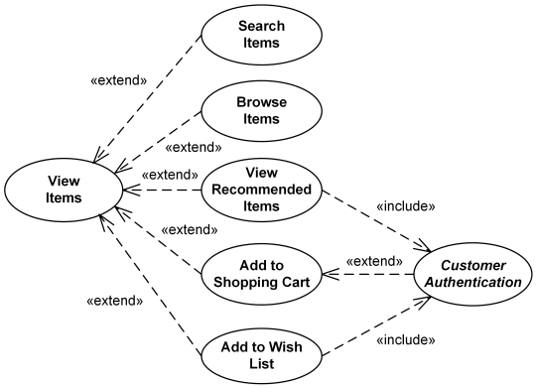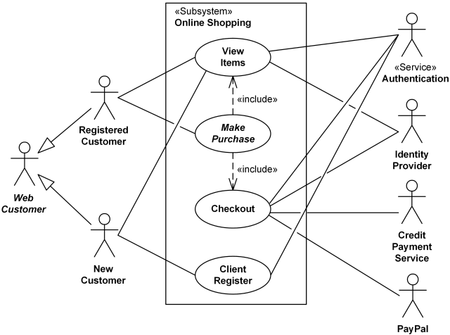*2.*

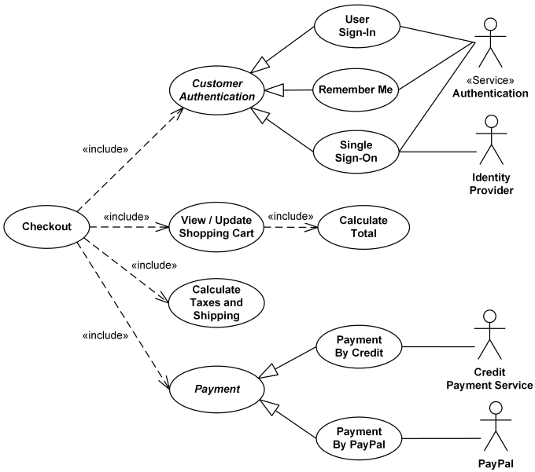

# Activity Diagrams

*1.*

*2.*

Customer Bookseller

*3.*

# Class Diagrams

*1.*

*2.*

*3.*

# Sequence Diagrams

1.

*2.*

*3.*

# Bibliography

ClickChartsFlowchartSoftware